**Обязательный минимум для студентов 1 курса**

**1 семестр**

Выполнив задания, студент получает «Зачет», отметку «3» в кафедральный журнал. На втором курсе по результатам обучения студент не может получить больше «4» на зачете с оценкой.

**ВСЕ ЗАДАНИЯ ПИСЬМЕННЫЕ!**

Выполнять письменно тетради. Писать полными предложениями. Ответы на вопросы – 2-3 предложения. Ответы в виде столбика слов не принимаются.

Конспекты видео материалов письменно, ориентироваться в конспектах.

1. **Watch a short video.**

<https://cloud.mail.ru/public/Uf9h/1GncioaMo>

What is the video about? Do you think education is important?

Watch the video one more time and write out the key phrases that explain why education is important.

1. **Answer the following discussion questions.**

1. Where did you go to school? Was it a good school?

2. Did you enjoy your time at school? Why or why not?

3. What was your favorite subject at school? Which subjects didn't you like? Why?

4. How can we stop children from becoming bored at school?

5. Did you have a favorite teacher? How about a least favorite? Can you describe these teachers? What are the best qualities in a teacher?

6. What were the most important things you learned at school?

7. Do you think the quality of education in schools is better today compared to when you went?

8. Do schools truly prepare children for their future?

1. **Do a writing exercise:**

Write a short article that you could use as a post in a social network to describe your idea of **what today`s university must be like**. 200 слов

1. **Watch a short video.**

<https://www.youtube.com/watch?v=q3e1vGQ0fOg>

What is the video about? What main aspects are covered?

1. What institutions provide for higher education in Britain?
2. What is the final stage of any HE course?
3. What do you need to pass to become a student
4. What is the average length of a course?
5. Where may the college or uni and its facilities be located
6. What places may students choose to live in?
7. Why is HE massively rewarding?

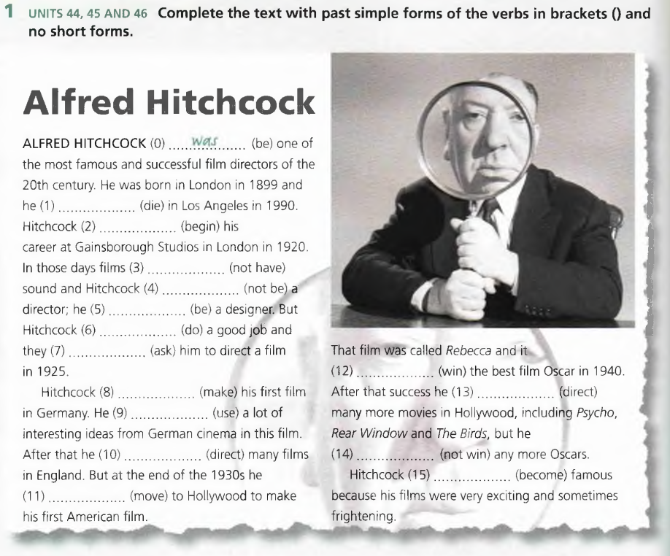

1. **Do a writing exercise:**

Write a short article that you could use as a post in a social network to describe your idea of **how different ia higher education in Britain and in the USA from that in Russia.** 150 слов

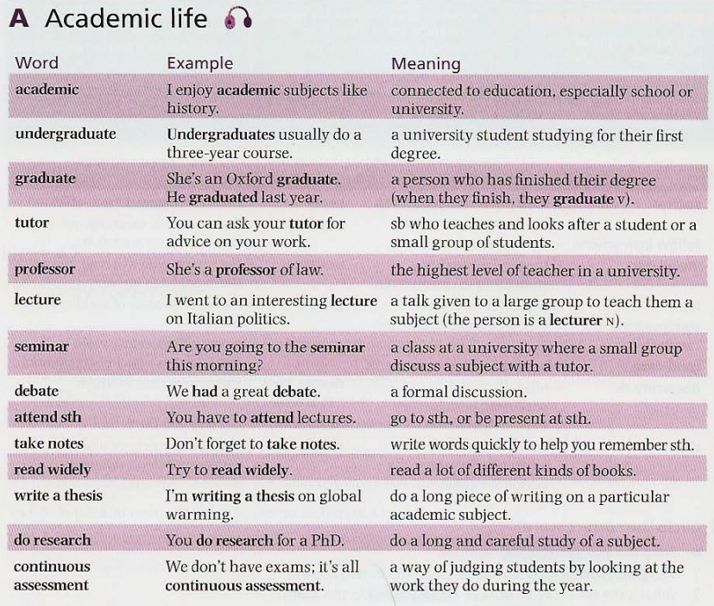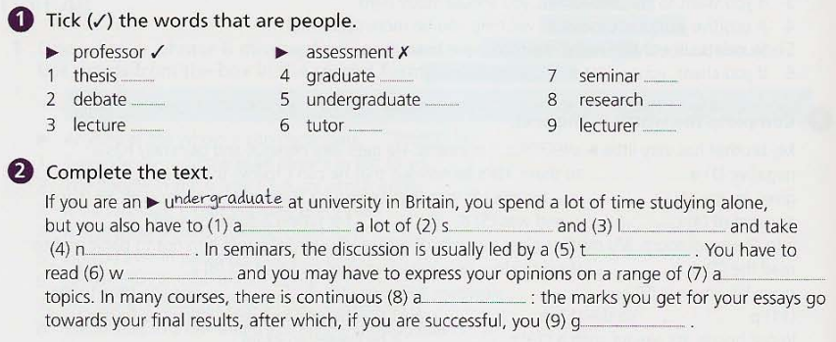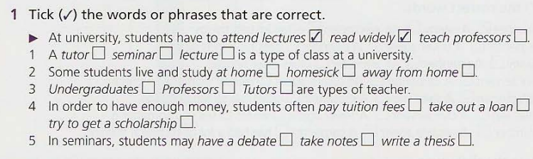

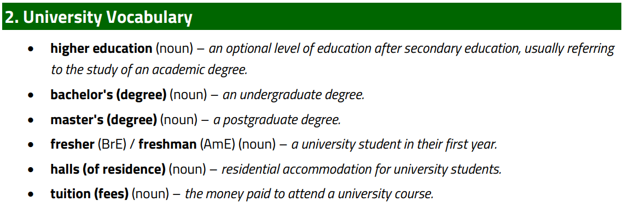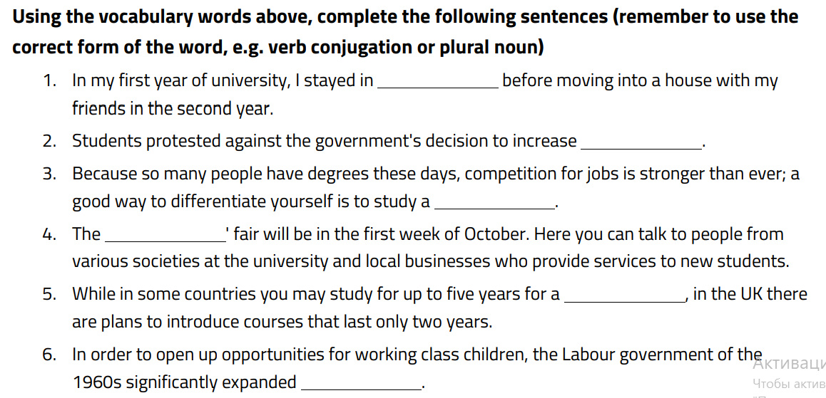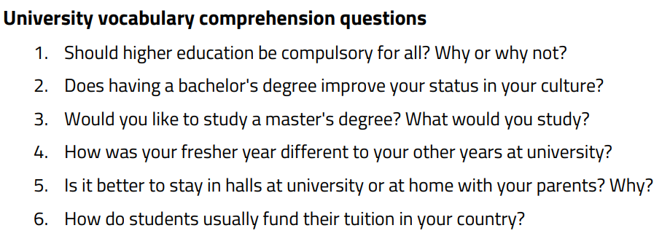

**Grammar task. Present simple with future meaning**

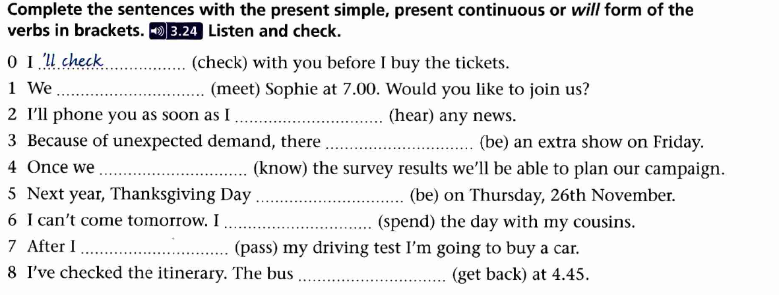



**Write the summary of the following video (Education as a human right), then write your own thoughts about what you have just seen (not less than 150 words) :** <https://yourenglishpal.com/blog/esl-conversation-lesson-plan-education/>

**Read the text and make notes (конспект на английском языке). Be ready to answer the queations. You can find the meaning (not translation!) of any word and write it down.**

# distance learning

**distance learning**, form of [education](https://www.britannica.com/topic/education) in which the main elements include physical separation of teachers and students during instruction and the use of various [technologies](https://www.britannica.com/technology/technology) to [facilitate](https://www.merriam-webster.com/dictionary/facilitate) student-teacher and student-student [communication](https://www.britannica.com/topic/communication). Distance learning traditionally has focused on nontraditional students, such as full-time workers, military personnel, and nonresidents or individuals in remote regions who are unable to attend classroom lectures. However, distance learning has become an established part of the educational world, with trends pointing to ongoing growth. In U.S. [higher education](https://www.britannica.com/topic/higher-education) alone, more than 5.6 million [university](https://www.britannica.com/topic/university) students were enrolled in at least one online course in the autumn of 2009, up from 1.6 million in 2002. Students of all ages, around the world, were forced into distance learning in early 2020 once the global [coronavirus pandemic](https://www.britannica.com/science/coronavirus-virus-group) resulted in the [widespread](https://www.britannica.com/dictionary/widespread) closure of many schools. [Videoconferencing](https://www.britannica.com/technology/videoconferencing) software such as [Zoom](https://www.britannica.com/technology/Zoom-software) gained greatly from this development. Zoom became one of the most popular services of its kind, one of the most downloaded applications worldwide, and a household word. Teaching, and the student-teacher relationship, was fundamentally changed.

An increasing number of universities provide distance learning opportunities. A pioneer in the field is the [University of Phoenix](https://www.britannica.com/topic/University-of-Phoenix), which was founded in Arizona in 1976 and by the first decade of the 21st century had become the largest private school in the world, with more than 400,000 enrolled students. It was one of the earliest adopters of distance learning technology, although many of its students spend some time in classrooms on one of its dozens of campuses in the [United States](https://www.britannica.com/place/United-States), Canada, and [Puerto Rico](https://www.britannica.com/place/Puerto-Rico). A precise figure for the international enrollment in distance learning is unavailable, but the enrollment at two of the largest public universities that heavily [utilize](https://www.britannica.com/dictionary/utilize) distance learning methods gives some indication: in the early 21st century the Indira Gandhi National Open University, headquartered in [New Delhi](https://www.britannica.com/place/New-Delhi), had an enrollment in excess of 1.5 million students, and the China Central Radio and TV University, headquartered in [Beijing](https://www.britannica.com/place/Beijing), had more than 500,000 students.

Students and institutions embrace distance learning with good reason. Universities benefit by adding students without having to construct classrooms and housing, and students reap the advantages of being able to work where and when they choose. Public-school systems offer specialty courses such as small-enrollment languages and Advanced Placement classes without having to set up multiple classrooms. In addition, [homeschooled](https://www.britannica.com/topic/homeschooling) students gain access to centralized instruction.

## Characteristics of distance learning

Various terms have been used to describe the phenomenon of distance learning. Strictly speaking, distance learning (the student’s activity) and distance [teaching](https://www.britannica.com/topic/teaching) (the teacher’s activity) together make up distance education. Common variations include e-learning or online learning, used when the [Internet](https://www.britannica.com/technology/Internet) is the medium; virtual learning, which usually refers to courses taken outside a classroom by primary- or secondary-school pupils (and also typically using the Internet); correspondence education, the long-standing method in which individual instruction is conducted by mail; and open learning, the system common in Europe for learning through the “open” university (see below).

Four characteristics distinguish distance learning. First, distance learning is by definition carried out through institutions; it is not self-study or a nonacademic learning [environment](https://www.merriam-webster.com/dictionary/environment). The institutions may or may not offer traditional classroom-based instruction as well, but they are eligible for accreditation by the same agencies as those employing traditional methods.

Second, geographic separation is [inherent](https://www.merriam-webster.com/dictionary/inherent) in distance learning, and time may also separate students and teachers. Accessibility and convenience are important advantages of this mode of education. Well-designed programs can also bridge [intellectual](https://www.merriam-webster.com/dictionary/intellectual), cultural, and social differences between students.

Third, interactive telecommunications connect individuals within a learning group and with the teacher. Most often, electronic communications, such as [e-mail](https://www.britannica.com/technology/e-mail), are used, but traditional forms of communication, such as the [postal system](https://www.britannica.com/topic/postal-system), may also play a role. Whatever the medium, interaction is essential to distance education, as it is to any education. The connections of learners, teachers, and instructional resources become less dependent on physical proximity as communications systems become more sophisticated and widely available; consequently, the Internet, [mobile phones](https://www.britannica.com/technology/mobile-telephone), and e-mail have contributed to the rapid growth in distance learning.

Finally, distance education, like any education, establishes a learning group, sometimes called a learning [community](https://www.merriam-webster.com/dictionary/community), which is composed of students, a teacher, and instructional resources—i.e., the books, audio, video, and graphic displays that allow the student to access the content of instruction. [Social networking](https://www.britannica.com/technology/social-network) on the Internet promotes the idea of community building. On sites such as [Facebook](https://www.britannica.com/money/Facebook) and [YouTube](https://www.britannica.com/topic/YouTube), users construct profiles, identify members (“friends”) with whom they share a connection, and build new [communities](https://www.merriam-webster.com/dictionary/communities) of like-minded persons. In the distance learning setting, such networking can enable students’ connections with each other and thereby reduce their sense of isolation.

## Early history of distance learning

## [Correspondence schools](https://www.britannica.com/topic/correspondence-education) in the 19th century

Geographical isolation from schools and dispersed religious congregations spurred the development of religious correspondence education in the United States in the 19th century. For example, the Chautauqua Lake Sunday School Assembly in western [New York](https://www.britannica.com/place/New-York-state) state began in 1874 as a program for training [Sunday school](https://www.britannica.com/topic/Sunday-school) teachers and church workers. From its religious origins, the program gradually expanded to include a nondenominational course of directed home reading and correspondence study. Its success led to the founding of many similar schools throughout the United States in the [chautauqua movement](https://www.britannica.com/topic/chautauqua-movement).

It was the demand by industry, government, and the military for [vocational training](https://www.britannica.com/topic/vocational-education), however, that pushed distance learning to new levels. In Europe, mail-order courses had been established by the middle of the 19th century, when the Society of Modern Languages in Berlin offered correspondence courses in French, German, and English. In the United States, companies such as Strayer’s Business College of Baltimore City (now Strayer University), which was founded in Maryland in 1892 and included mail-order correspondence courses, were opened to serve the needs of business employers, especially in the training of women for secretarial duties. Most nonreligious mail-order correspondence courses emphasized instruction in spelling, grammar, business letter [composition](https://www.merriam-webster.com/dictionary/composition), and bookkeeping, but others taught everything from developing [esoteric](https://www.merriam-webster.com/dictionary/esoteric) mental powers to operating a beauty salon. The clear leader in correspondence course instruction in American higher education at the end of the 19th century was the [University of Chicago](https://www.britannica.com/topic/University-of-Chicago), where [William Rainey Harper](https://www.britannica.com/biography/William-Rainey-Harper) employed methods that he had used as director of the Chautauqua educational system for several years starting in 1883.

## Early educational theories and technologies

## [Behaviourism](https://www.britannica.com/science/behaviourism-psychology) and constructivism

During the first half of the 20th century, the use of educational technology in the United States was heavily influenced by two developing schools of [educational philosophy](https://www.britannica.com/topic/philosophy-of-education). [Behaviourism](https://www.britannica.com/science/behaviourism-psychology), led by the American psychologist [John B. Watson](https://www.britannica.com/biography/John-B-Watson) and later by [B.F. Skinner](https://www.britannica.com/biography/B-F-Skinner), discounted all subjective mental phenomena (e.g., [emotions](https://www.britannica.com/science/emotion) and mental images) in favour of objective and measurable behaviour. The constructive approach arose from ideas on [progressive education](https://www.britannica.com/topic/progressive-education) advanced by the American philosopher [John Dewey](https://www.britannica.com/biography/John-Dewey) and others, who [emphasized](https://www.britannica.com/dictionary/emphasized) the education of the “whole child” to achieve intellectual, physical, and emotional growth and argued that learning is best accomplished by having children perform tasks rather than memorize facts. Constructivism, whose leading figure was the French developmental psychologist [Jean Piaget](https://www.britannica.com/biography/Jean-Piaget), asserted that learning arises from building mental models based on experience. These theories led to different techniques for the use of media in the classroom, with behaviourism concentrating on altering student behaviour and constructivism focusing on process- and experience-based learning.

## Technological aides to education

One of the first technological aides to education was the lantern slide (e.g., the [Linnebach lantern](https://www.britannica.com/art/Linnebach-lantern)), which was used in the 19th century in chautauqua classes and [lyceum](https://www.britannica.com/topic/lyceum-movement) schools for adults and in traveling public-lecture tent shows throughout the world to project images on any convenient surface; such visual aides proved particularly useful in educating semiliterate audiences. By the start of the 20th century, learning theories had begun concentrating on visual approaches to instruction, in contrast to the oral recitation practices that still dominated traditional classrooms.

The first significant technological [innovation](https://www.merriam-webster.com/dictionary/innovation) was made by the American inventor [Thomas Edison](https://www.britannica.com/biography/Thomas-Edison), who devised the tinfoil [phonograph](https://www.britannica.com/technology/phonograph) in 1877. This device made possible the first language laboratories (facilities equipped with audio or audiovisual devices for use in language learning). After [World War I](https://www.britannica.com/event/World-War-I), university-owned radio stations became commonplace in the United States, with more than 200 such stations broadcasting recorded educational programs by 1936.

Edison was also one of the first to produce [films](https://www.britannica.com/art/motion-picture) for the classroom. Many colleges and universities experimented with educational film production before World War I, and training films were used extensively during the war to educate a [diverse](https://www.merriam-webster.com/dictionary/diverse) and often illiterate population of soldiers in a range of topics from fighting technique to personal hygiene. Improvements in filmmaking, in particular the ability to produce “talkies,” were put to use just before and during [World War II](https://www.britannica.com/event/World-War-II) for technical training and [propaganda](https://www.britannica.com/topic/propaganda) purposes. While the most artistically acclaimed [propaganda](https://www.merriam-webster.com/dictionary/propaganda) production may have been Triumph of the Will (1935), one of a series of films made by [Leni Riefenstahl](https://www.britannica.com/biography/Leni-Riefenstahl) during the 1930s for the German Nazi government, similar films were produced by all the major [belligerents](https://www.merriam-webster.com/dictionary/belligerents). In the United States the army commissioned Hollywood film director [Frank Capra](https://www.britannica.com/biography/Frank-Capra) to produce seven films, the widely acclaimed series Why We Fight (1942–45), in order to educate American soldiers on what was at stake.

Instructional [television](https://www.britannica.com/technology/television-technology) courses began to be developed in the 1950s, first at the [University of Iowa](https://www.britannica.com/topic/University-of-Iowa). By the 1970s [community colleges](https://www.britannica.com/topic/junior-college) all across the United States had created courses for broadcast on local television stations. Various experiments in computer-based education also began in the 1950s, such as programmed or [computer-assisted instruction](https://www.britannica.com/topic/computer-assisted-instruction), in which computers are used to present learning materials consisting of text, audio, and video and to evaluate students’ progress. Much of the early research was conducted at [IBM](https://www.britannica.com/money/International-Business-Machines-Corporation), where the latest theories in [cognitive science](https://www.britannica.com/science/cognitive-science) were incorporated in the application of educational technology. The next major advancement in educational technology came with the linking of computers through the [Internet](https://www.britannica.com/technology/Internet), which enabled the development of modern distance learning.

# Modern distance learning

## Web-based courses

By the beginning of the 21st century, more than half of all two-year and four-year degree-granting institutions of [higher education](https://www.britannica.com/topic/higher-education) in the [United States](https://www.britannica.com/place/United-States) offered distance education courses, primarily through the [Internet](https://www.britannica.com/technology/Internet). With more than 100,000 different online courses to choose from, about one-quarter of American students took at least one such course each term. Common target populations for distance learning include professionals seeking recertification, workers updating employment skills, individuals with disabilities, and active military personnel.

Although the theoretical trend beginning in the 1990s seemed to be toward a stronger reliance on video, audio, and other multimedia, in practice most successful programs have predominately utilized electronic texts and simple text-based communications. The reasons for this are partly practical—individual instructors often bear the burden of producing their own multimedia—but also reflect an evolving understanding of the central benefits of distance learning. It is now seen as a way of [facilitating](https://www.merriam-webster.com/dictionary/facilitating) communication between teachers and students, as well as between students, by removing the time constraints associated with sharing information in traditional classrooms or during instructors’ office hours. Similarly, self-paced software educational systems, though still used for certain narrow types of training, have limited flexibility in responding and adapting to individual students, who typically demand some interaction with other humans in formal educational settings.

Modern distance learning courses employ Web-based course-management systems that incorporate digital reading materials, podcasts (recorded sessions for electronic listening or viewing at the student’s leisure), [e-mail](https://www.britannica.com/technology/e-mail), threaded (linked) discussion forums, chat rooms, and test-taking functionality in [virtual](https://www.britannica.com/technology/virtual-reality) (computer-simulated) classrooms. Both [proprietary](https://www.merriam-webster.com/dictionary/proprietary) and [open-source](https://www.britannica.com/topic/open-source) systems are common. Although most systems are generally asynchronous, allowing students access to most features whenever they wish, synchronous technologies, involving live video, audio, and shared access to electronic documents at scheduled times, are also used. Shared social spaces in the form of [blogs](https://www.britannica.com/topic/blog), [wikis](https://www.britannica.com/topic/wiki) (Web sites that can be modified by all classroom participants), and collaboratively edited documents are also used in educational settings but to a lesser [degree](https://www.britannica.com/topic/degree-education) than similar spaces available on the Internet for socializing.

## Web-based services

Alongside the growth in modern institutional distance learning has come Web-based or [facilitated](https://www.merriam-webster.com/dictionary/facilitated) personal educational services, including e-tutoring, e-mentoring, and research assistance. In addition, there are many educational assistance companies that help parents choose and contact local tutors for their children while the companies handle the contracts. The use of distance learning programs and tutoring services has increased particularly among parents who [homeschool](https://www.britannica.com/topic/homeschooling) their children. Many universities have some online tutoring services for [remedial](https://www.merriam-webster.com/dictionary/remedial) help with reading, writing, and basic mathematics, and some even have online mentoring programs to help doctoral candidates through the dissertation process. Finally, many Web-based personal-assistant companies offer a range of services for adults seeking [continuing education](https://www.britannica.com/topic/adult-education) or professional development.

## [Open universities](https://www.britannica.com/topic/Open-University-British-education)

One of the most prominent types of educational institutions that makes use of distance learning is the open [university](https://www.britannica.com/topic/university), which is open in the sense that it admits nearly any adult. Since the mid-20th century the open university movement has gained momentum around the world, reflecting a desire for greater access to higher education by various [constituencies](https://www.merriam-webster.com/dictionary/constituencies), including nontraditional students, such as the disabled, military personnel, and prison inmates.

The origin of the movement can be traced to the [University of London](https://www.britannica.com/topic/University-of-London), which began offering degrees to external students in 1836. This paved the way for the growth of private correspondence colleges that prepared students for the University of London’s examinations and enabled them to study independently for a degree without formally enrolling in the university. In 1946 the University of [South Africa](https://www.britannica.com/place/South-Africa), headquartered in Pretoria, began offering correspondence courses, and in 1951 it was reconstituted to provide degree courses for external students only. A proposal in Britain for a “University of the Air” gained support in the early 1960s, which led to the founding of the [Open University](https://www.britannica.com/topic/Open-University-British-education) in 1971 in the so-called [new town](https://www.britannica.com/topic/new-urbanology) of [Milton Keynes](https://www.britannica.com/place/Milton-Keynes). By the end of the 1970s the university had 25,000 students, and it has since grown to annual enrollments in the hundreds of thousands. Open universities have spread across the world and are characterized as “mega-universities” because their enrollments may exceed hundreds of thousands, or even millions, of students in countries such as India, China, and Israel.

As one of the most successful nontraditional institutions with a research component, the Open University is a major contributor to both the administrative and the [pedagogical](https://www.merriam-webster.com/dictionary/pedagogical) literature in the field of open universities. The university relies heavily on prepared materials and a tutor system. The printed text was originally the principal [teaching](https://www.britannica.com/topic/teaching) medium in most Open University courses, but this changed somewhat with the advent of the Internet and computers, which enabled written assignments and materials to be distributed via the Web. For each course, the student is assigned a local tutor, who normally makes contact by [telephone](https://www.britannica.com/technology/telephone), mail, or e-mail to help with queries related to the academic materials. Students may also [attend](https://www.britannica.com/dictionary/attend) local face-to-face classes run by their tutor, and they may choose to form self-help groups with other students. Tutor-graded assignments and discussion sessions are the core aspects of this educational model. The tutors and interactions between individual students are meant to compensate for the lack of face-to-face lectures in the Open University. To emphasize the tutorial and individualized-learning aspects of its method, the Open University prefers to describe it as “supported open learning” rather than distance learning.

Read the text and do the tasks inside the text. Be sure you know the terms. Then be ready to discuss and answer the questions.

**Protection and conservation of endangered types of Flora and Fauna**

As the impact of human activities on the environment continues to grow, it becomes increasingly important for governments to take proactive measures to ensure the survival of various plant and animal species.

**Legislative Measures to Safeguard Wildlife**

The governments all over the world implemented a series of legislative measures to protect and conserve our precious flora and fauna. These laws are diverse and play a critical role in our [conservation efforts](https://www.appgecet.co.in/the-two-main-aims-of-wildlife-conservation-protecting-nature-for-a-sustainable-future/).

#### **Tax Incentives for Conservation**

The government recognizes the importance of encouraging individuals and organizations to actively participate in conservation efforts. They have introduced tax incentives that provide substantial benefits to those who contribute to the preservation of our flora and fauna. By offering tax breaks, the government hopes to inspire a greater sense of responsibility and engagement from the public.

### National Parks and Protected Areas

One of the government’s most visually striking endeavors is the establishment and maintenance of national parks and protected areas throughout the country. These scenic wonders not only provide breathtaking landscapes and recreational opportunities but also serve as safe havens for countless species of plants and animals.

### Conservation Education and Awareness

The government believes that education is the key to fostering an understanding and appreciation for the importance of conservation. By implementing nationwide programs and campaigns, they are actively engaging citizens of all ages in the pursuit of environmental stewardship.

**Sustainable Future: Educating the Next Generation**

The Sustainable Future initiative is a compelling example of the government’s dedication to educating the youth about the significance of conservation. This program introduces school curricula focused on environmental sustainability, raising awareness and empowering future generations to play an active role in protecting our flora and fauna.

### International Collaborations

Understanding that conservation is a global effort, the government has actively sought partnerships and collaborations with international organizations. By joining forces with like-minded countries, they are able to share knowledge, resources, and expertise, further amplifying the impact of their conservation efforts.

Human conservation efforts primarily concentrate on two strategies: preserving the conditions in which plants and animals thrive, and avoiding the death of the animals and plants themselves. The goal of conservation is to protect future resources. However, economic opportunity frequently pushes humans to modify habitats and exploit plant and animal species, often to the brink of extinction. At times, the nature of economics clashes with conservation. Because scarcity makes a resource more desirable to anyone who can still obtain it, incentives grow as supplies decline.

### Possible Ways of Conservation

Here are some possible ways to conserve plants and animals:

**1. Plant and Animal Habitats Should be Protected.**

While people use animals and plants as resources, their habitat may also be valuable. Africa is full of examples of forest areas converted to agriculture, culminating in biodiversity loss. Agriculture and aquaculture are displacing coastal mangroves all across the world, and urbanization is also destroying many species' natural habitats. So, these habitats should be protected.

**2. The Amount of Time that Humans Spend on Animals and Plants Should be Reduced.**

As people's living conditions improve in emerging nations, there is a greater demand for meat production since more customers can buy meat for eating. This increases the demand for natural resources that are used to manufacture meat. For example, the grains used to feed animals in the United States could support 800 million people. As a result, humans are destroying more natural habitats to meet the need for meat. Choosing to consume less meat in one's meals would lower the demands on most of the resources necessary to produce it, from food to water to space.

**3. Market Forces the Animal and Plant Resources to Become Scarce.**

African elephants and rhinos ivories are examples of decreasing animal resources. When these species become prey to cartel gunmen, their tusks and horns become increasingly scarce and precious. Buyers stockpile ivory in the hope of increasing its future value. Rates for Asian wood products such as rosewood have surged by up to 90% in the last year. In each case, safeguarding animals and plants resources necessitates a struggle against market pressures, such as a prohibition on the sale of ivory and curbs on logging exports.

**4. Consider How Solutions Might have Unintended Consequences.**

In the complexities of Earth's natural ecology, a good concept might have unforeseen repercussions. Hydroelectric dams create power from the energy of the stream, which sounds good because it decreases the usage of fossil fuels. Dams, on the other hand, obstruct fish migratory paths. Wind turbines produce power without polluting the [environment](https://www.vedantu.com/biology/environment), but there is great disagreement regarding how several birds they kill.

### Deforestation

It is the cutting of trees for human benefits. With forest wood, humans are hugely benefited in various ways including firewood, paper production, house building, furniture manufacturing, and other artworks. Here, we will start with the causes and effects of deforestation (one of the most important factors that make it necessary to conserve plants and animals).

### Match words to their definitions/ Man-made causes.

### How do these processes influence the habitat of the animals and birds?

|  |  |
| --- | --- |
| Urbanization | 1. **-** For obtaining wood, people cut many trees. |
| Mining | 1. It is the process of cutting trees, processing them and loading them into trucks or cars. |
| Timber | 1. Constructing more buildings and houses. |
| Paper Industry | 1. **-** Paper is obtained from wood and it requires cutting down a large amount of trees. |
| Logging | 1. Mining activities also lead to deforestation. |

**Natural Causes**

* Forest fires
* Barren Lands
* Hurricanes
* Pests
* Droughts

### Effects of Deforestation

1. Decrease in temperature leading to global warming
2. Desertification where lands turn into dry lands or deserts, without trees and receiving no rainfall.
3. Change in rainfall patterns as trees are useful to maintain the climatic conditions.
4. Soil erosion leading to washing away of soil layers useful for plantation.
5. Floods which are natural disasters that may take up many lives.
6. What does biodiversity mean?
7. Is it important to maintain biodiversity?

### Biodiversity (Flora and Fauna of an Area)

Conservation of plants and animals topic also covers biodiversity and the different terms associated with the biodiversity are as follows:

**Task. Match the phrases to their definitions**

|  |  |
| --- | --- |
| 1. **Species** | 1. It is a linear sequence of organisms dependent on each other, starting from producers to consumers to decomposers. |
| 1. **Food Chain** | 1. All plants, animals, microorganisms, soil, water and air together constitute an ecosystem that helps the survival of living organisms. Ecosystem consists of biotic (with life) and abiotic (without life) factors as mentioned here. |
| 1. **Endemic Species** | 1. A group of interbreeding individuals are called species. |
| 1. **Ecosystem** | 1. Those species which are found only in a particular area and cannot be found anywhere else are called endemic species. |

### Biodiversity Conservation

It is the flora and fauna of an area and maintaining rich diversity will help in conservation of plants and animals. Biodiversity is managed or protected from destruction with the help of the following establishments:

**1. Biosphere Reserve**

It allows research and education to zoologists and botanists who are studying plants and animals. It helps them gain knowledge about different flora and fauna. An example of biosphere reserve is Pachmarhi biosphere reserve where Sal trees and Wild Mango are found as flora and flying squirrel and Cheetal are among fauna found there.

**2. National Park**

It is a highly restricted area where no human activity is allowed. It protects the historic and cultural heritage of the area. For example, rock shelters and caves were discovered in Satpura National Park where no human activity is allowed.

**3. Wildlife Sanctuaries**

It conserves wild animals in their natural habitat and limited human activity is only allowed here. No one is allowed to perform hunting, poaching and deforestation.

**4. Tiger Reserves**

It was launched in 1973 and is especially meant for conserving tigers. Tiger being a National animal of India is highly taken care of.

### Species and Different Kinds of Species

A group of interbreeding individuals are called species.

|  |  |
| --- | --- |
| 1. **Vulnerable Species** | * 1. Species which no longer exist are called extinct species. **Examples:** Dinosaurs and Dodo. |
| 1. **Endangered Species** | * 1. Species that are at the highest risk of extinction are critically endangered species.   **Examples:** Hawksbill and Orangutan |
| 1. **Critically Endangered Species** | * 1. Species that are at a high risk of extinction. **Examples:** Bonobo and Blue Whale |
| 1. **Extinct Species** | * 1. Those species that are about to become endangered. **Examples:** Giant Panda and Polar Bear. |

**Questions to discuss.**

1. What measures are taken by governments to protect and conserve plants and animals?
2. What main strategies do human conservation efforts primarily concentrate on?
3. What are the ways to persuade people to appreciate the importance of animal and plant conservation?
4. What are possible ways to conserve plants and animals?
5. What man-made causes of deforestation can you name?
6. What about natural causes of deforestation?
7. What can be the effects of deforestation?
8. What are the different types of Species?
9. How does conservation of plants and animals help in a Healthy Environment?
10. Why do we need to conserve plants and animals?
11. What does biodiversity imply?

Give the definitions to the following words and make a story, using all of them. The story must be based on communication and its means:

Converse, accurate, distract, bias, frank, gossip, verbal, witty, perspective, dry, genuine, interaction, imply, clarify.

**Reported speech.**

[**https://youtu.be/eplQBhE0-Hg?si=b20qjAmXIzZN_0T3**](https://youtu.be/eplQBhE0-Hg?si=b20qjAmXIzZN_0T3)

[**https://youtu.be/cW3pdeTYFZc?si=SgEzR_swU_YZ2s4R**](https://youtu.be/cW3pdeTYFZc?si=SgEzR_swU_YZ2s4R)

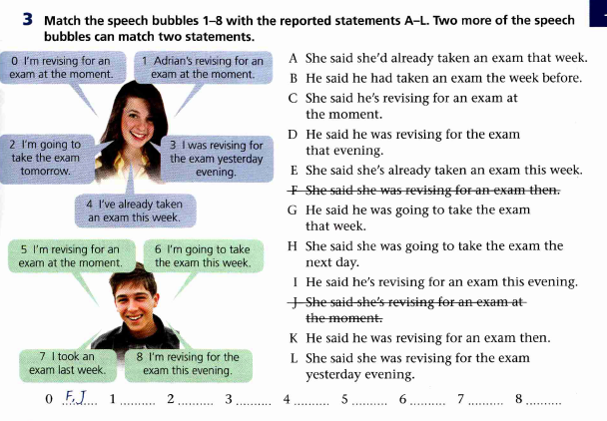

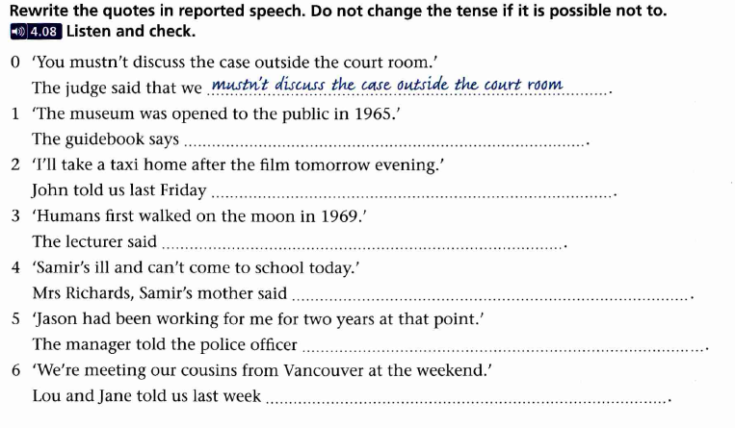

**Match the names with the texts, try to fill in missing words as well**.

Written Communication

Visual Communication

Feedback Communication

Mass Communication

Non-Verbal Communication

Group Communication

Interpersonal communication

Oral Communication

Verbal Communication

Public Communication

**Types of Communication**

____________Communication

In ……. communication words of a particular language are used for passing the message. For example, while teaching in a class teacher speaks, and writes on the blackboard, or sometimes, he/she may use audio/visual aids, such as the power-point to explain/emphasize certain points. All these modes come under the category of verbal communication. Thus, …….. communication is of two types.

____________communication

…………. communication takes place between two persons. This includes dialogue, conversation, or exchange of views between two persons without using any technological devices like the telephone. It is direct, intimate, and consists of verbal interaction or gestures.

____________ Communication

This is the communication that employs the spoken word, either direct or indirect as a communication channel. This ………. communication could be made on a channel that passes information in only one form i.e. sound.

_______________ Communication

In ………… communication, the sender-receiver (the speaker) sends a message (the speech) to an audience. The speaker usually delivers a highly structured message, using the same channels as in ……….. and small-group communication.

______________ Communication

Communication without using words, such as gestures, body language, the facial expressions is called …………… communication. Often ……………… expressions supplement verbal communication, but it may be the only one as mentioned earlier, while giving a speech in a rally, the leader often uses gestures, to emphasize certain points. But the teacher may allow a student to enter the class simply by the gesture. Non-verbal communication is of the following types:

Body Language (Kinesics)

Facial Expressions

Posture

Gestures

Touch

Proxemics

Appearance and Artifacts

Paralanguage

Written Communication

This kind of communication involves any kind of exchange of information in written form. To put it simply, written language communication is communication by means of written symbols that are communicated by or to, or between people or groups. Thus, written communication is the presentation of ideas or essays that make a clear point, supply details supporting that point, and demonstrate unity and coherence of thought.

When the information is lengthy and comprises images, pictures, charts, graphs, statistical data, and so forth, then it cannot be imparted orally to the individuals. In such cases, written communication is regarded as one of the indispensable ways of imparting information.

_____________Communication

……….. communication is also the type of communication that is common in the daily lives of individuals. The main areas through which visual communication takes place are televisions, radios, social networking, and so forth. When individuals are watching television or listening to radio programs, then also they are engaged in a form of communication.

In some cases, they are not only utilizing these for leisure and recreational purposes, but they are also augmenting their knowledge and understanding in terms of various aspects. When individuals are communicating with others, then in most cases, their objective is to enhance their knowledge and understanding.

Therefore, through some television shows and radio programs as well, individuals are able to augment their knowledge and understanding. Facebook is visual with the use of memes, videos, images, and so forth. Instagram is the only image platform, and advertisers make use of this platform to market their products.

______________ Communication

When individuals, who are in leadership positions in educational institutions and in various forms of organizations, such as instructors, supervisors, heads, directors, employers, and so forth, put into operation various types of assessment methods to evaluate the performance of the individuals.

After evaluating the performance, they provide …………….in terms of their performance. Hence, the communication that takes place is termed ………. communication. . Therefore, within educational institutions at all levels and various types of organizations, this type of communication is regarded as crucial and beneficial.

____________ Communication

…………. Communication is the process of delivering information, ideas, and attitudes to a sizeable and diversified audience. This is done through the use of media developed for that purpose namely newspapers, magazines, radio, television, websites, and social media networks. The act of mass communication is much more complex than that of face-to-face communication. It is addressed to the masses, to an extremely large audience.

__________ Communication

Communication by many persons in a face-to-face situation is described as ……….. communication. Here, as the group grows in size communication tends to become more and more of a monologue reducing participation. The degree of directness, therefore, depends on the size of the group, the place where it meets, and also the relationship of the members of the group to one another. In a group, communication feedback is more difficult to measure and respond to.

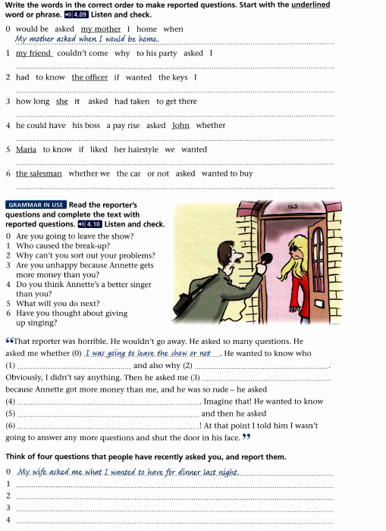

**Lexical tasks**

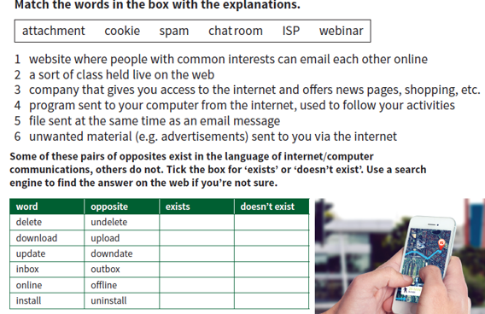

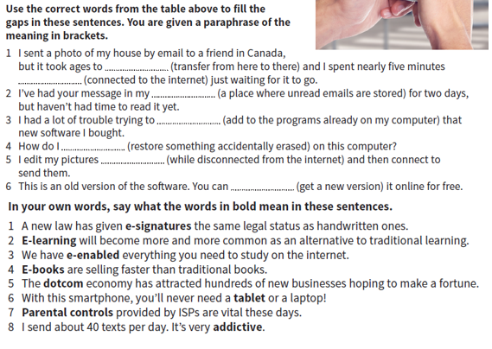

*Look through the video.*

<https://www.youtube.com/watch?v=H1HGQcqfRFY>

*What is the video about? What three terms are discussed? Write out the key phrases that the speaker uses to explain the meaning of these terms.*

*Give the definitions to the following words and make sentenses, using the words.*

* **Increasingly**
* **Concerns**
* **Pace**
* **Perception**
* **Seamless**
* **Strides**
* **Wellness**
* **Customize**
* **Profoundly**

**Read the text to answer the questions below:**

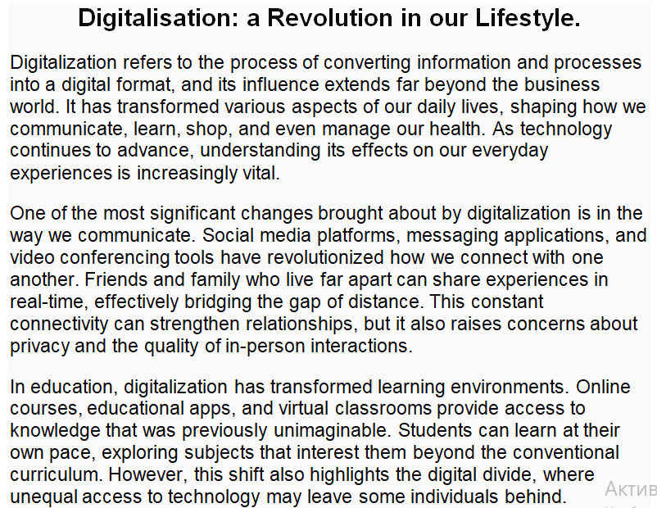

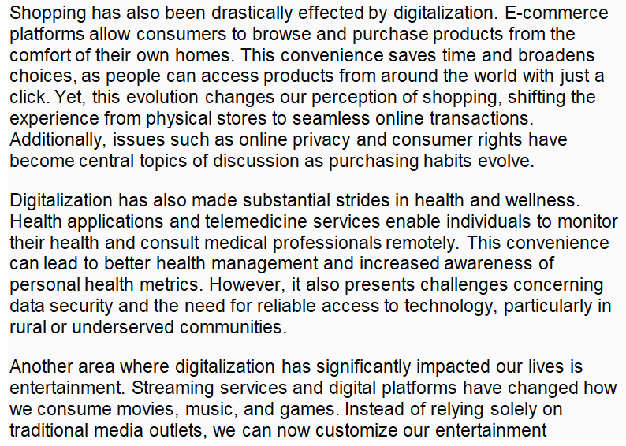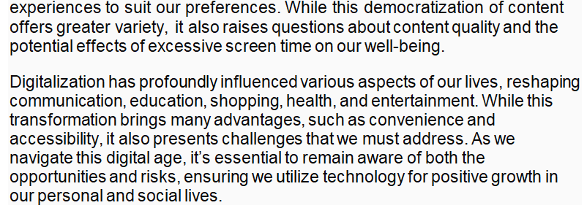

1. **What is digitalisation, and what does it involve?**
2. **How has digitalisation changed communication among people?**
3. **In what ways has education been transformed by digitalisation?**
4. **Describe the impact of digitalisation on shopping.**
5. **What challenges are associated with digital health applications and telemedicine?**
6. **How has entertainment changed due to digitalisation?**
7. **What key advice does the text suggest about navigating the digital era?**

***Security measures when using communication tools*.**

**Write a detailed summary of the video.**

**Write 10 questions so that the answers can be found in the video.**

<https://youtu.be/yqJvcDB72mc?si=zvXYGsULFPshffDd>

**Read and be ready to retell the text.**

**Text**

The problems of information security are constantly aggravated by the processes of penetration into almost all spheres of society's activities of technical means of processing and transmitting data and, above all, computing systems. To date, three basic principles of information security have been formulated, which should ensure: data integrity - protection against failures leading to loss of information, as well as unauthorized creation or destruction of data; confidentiality of information; accessibility for all authorized users.

The theory of information protection is defined as a system of basic ideas related to the protection of information in modern systems of its processing, giving a holistic view of the essence of the problem of protection, the patterns of its development and significant links with other branches of knowledge.

A strategy is a general, forward — looking guideline for the organization and provision of an appropriate type of activity, aimed at ensuring that the most important goals of this activity are achieved with the most rational use of available resources.

The organization of information protection in its most general form can be defined as the search for an optimal compromise between the protection needs and the resources necessary for these purposes.

The need for protection is primarily determined by the importance and volume of the protected information, as well as the conditions of its storage,

processing and use. These conditions are determined by the level (quality) of the structural and organizational structure of the information processing object, the level of organization of technological processing schemes, the location and conditions of the object and its components, and other parameters.

The amount of resources for information protection may be limited by a certain limit or determined by the condition of mandatory achievement of the required level of protection. In the first case, the protection must be organized in such a way that, with the allocated resources, the maximum possible level of protection, and in the second case, so that the required level of protection is provided with minimal resource consumption.

Thus, in the most general form, the composition and content of the first component of the scientific and methodological basis of the theory of protection - general methodological principles can be presented. The second component of this The basis is an instrumental and methodological base. The methodological basis, as the second component of the theory of protection, consists of a set of methods and models necessary and sufficient for researching the problem of protection and solving practical problems of appropriate purpose.

The formation of these methods is greatly influenced by the fact that information security processes are strongly influenced by random factors, and especially those that are associated with malicious actions of people who violate security. The same the methods, the harmonious structure of which is formed in the classical theory of systems, were developed in relation to the needs of creating, organizing and ensuring the functioning of technical, i.e., fundamentally formal systems.

The adequacy of these methods to meet these needs has been proven by the practice of many decades. Due to the above, the task of expanding the complex of methods of classical systems theory by including such methods in it that allow us to adequately model processes, significantly depending on the impact of difficult to predict factors.

The statement of the task of information protection, formed on the basis of an analysis of modern concepts of information support for activities in various fields and a retrospective analysis of the development of approaches to protection, represents, as it were, a concentrated expression of objective protection needs.

**Revision.** **Adjectives. Adverbs. Degrees of Comparison.**

Ex 1. Give the correct forms of the adverbs in brackets.

1. The (much) you read the (soon) you enlarge your vo­cabulary. 2. Our pilots fly (high) of all, (far) of all, and (fast) of all. 3. Am I speaking loud enough or shall I speak (loud)? 4. Yesterday he came home (late) than usual. 5. Becky Sharp said she had been treated (badly) than any servant in the kitchen. 5. Rebecca sang far (well) than Amelia. 7. We were far from our homes, but Mary suggested that we should go still (far), saying there were beautiful places in this neigh­bourhood. 8. We envied John, for he lived (near) of all; it took him the least time to get to the office. 9. We all ran pretty fast, but Sam ran (quickly) then I, Dick ran (fast), however. 10. I like this picture (well) of all. 11. There is no better death than dying to save the one you love (much) of all. 12. Then Oskey approached the fence (close), and dropped his voice to the confidential.

Ex. 2 Choose the appropriate adverb.

1. His heart was (deep, deeply) moved. 2. The tunnels of the Moscow Metro are dug-(deep, deeply) below the surface of the earth. 3. The idea seemed (high, highly) improbable to everybody. 4. The plane soared (high, highly), we could (hard, hardly) see it. 5. You will have to work real (hard, hardly) to get everything done as planned. 6. The mechanic (close, closely) examined the machine. 7. He approached me (closer, more closely), to hear me well. 8. He was (near, nearly) run over by the car. 9. He lives quite (near, nearly). 10. I have seen very little of him (late, lately). 11. You’ve come too (late, lately). 12. She always came (pretty, prettily) dressed. 13. It is (pretty, prettily) difficult to speak to her. 14. The train passed by whistling (loud, loudly). 15. Do I speak (loud, loudly) enough? 16. You paid too (dear,’ dearly) for this radio-set. 17. The father loved his daughter (dear, dearly). 18. Through a space in the trees I could see the house door; it was (wide, widely) open. 19. Gorky's works are (wide, widely) known throughout the world.

Ex.3 Choose the appropriate word and state whether it is an adjective or an adverb.

1. a) His head is full of ... ideas, b) They always speak ... of him. c) We ... appreciate your kindness (high, highly). 2. a) All was settled ... between us. b) You don't play ... . c) Why are you backing out? It isn't ... (fair, fairly). 3. a) She cut him ..., saying it was not to the point, b) He came to live there ... after the war. c) Speak ... (short, shortly). 4. a) They ... spoke during the walk, b) It was a pity he took life so ... . c) Try again, try ... (hard, hardly). 5. a) He tried to trans­late it as ... to the text as possible, b) It was ... in the room, c) He felt he was being ... watched (close, closely). 5. a) I found him ... in thought, b) I found him ... engrossed in read­ing the manuscript, c) Still waters run ... (deep, deeply). 7. a) The engine is ... to operate and its every part can be ... replaced, b) Take it ... . c) He is an ...-going man (easy, easily). 8. a) We were ... welcomed, b) She put a tea-cosy on the pot to keep it.... c) Don't dress the child too ... (warm, warmly). 9. a) Here is some work for you; see that you do it... . b) The Pamir is ... called "the world's roof", c) The car stopped ... in the middle of the road (right, rightly). 10. a) "How are you?" "Very..., thank you." b) "How's fife?" "Very..., thank you."c) "How are you getting on?" "Very..., thank you" (good, well).

***Speaking*.**

1. Why do you think pollution has become such a significant problem in the modern world?
2. Should governments be held responsible for addressing pollution?
3. How can we influence the world's pollution problem in the face of accelerating global urbanisation?
4. What are the possible solutions to this problem?

Discussion:

1. How does pollution affect human health?
2. How can the effects of pollution on humans be prevented? What ways of solving this problem can you suggest?
3. What do you do to stay healthy in a poor environment?

***Reading*.**

Read the text and answer the questions below.

**Social Institutions and Their Activities in the Environmental Sphere**

Social institutions play a critical role in shaping the relationship between society and the environment. Comprising a range of organizations such as the government, non-governmental organizations (NGOs), educational institutions, communities, and businesses, these entities are integral in responding to environmental challenges and promoting sustainable practices. This text explores the various activities of social institutions in the environmental sphere and their contributions to ecological well-being.

The Role of Government Institutions

Government authorities are essential players in environmental governance. They establish policies and regulations aimed at protecting natural resources and maintaining ecological balance. These institutions assess environmental conditions, enforce laws, and regulate activities that impact the environment, such as industrial emissions, waste disposal, and land use.

For example, environmental protection agencies in various countries develop frameworks to monitor and improve air and water quality. They collaborate with research institutions to gather data on environmental issues and informed decision-making. Additionally, governments often initiate programs to promote renewable energy usage, conservation efforts, and disaster preparedness in response to climate change.

Engagement of Non-Governmental Organizations (NGOs)

NGOs are instrumental in raising awareness, conducting advocacy, and mobilizing community action towards environmental issues. These organizations focus on specific areas such as wildlife conservation, climate change, pollution reduction, and sustainable development. By conducting research, hosting campaigns, and providing educational resources, NGOs engage the public and influence policy changes.

Prominent NGOs, like the World Wildlife Fund (WWF) and Greenpeace, work to protect endangered species, promote environmental justice, and initiate campaigns for clean energy alternatives. Through partnerships with communities, businesses, and government agencies, NGOs can address local environmental issues effectively and advocate for sustainable practices.

Educational Institutions as Catalysts for Change

Educational institutions play a vital role in fostering environmental stewardship and awareness. Schools and universities integrate environmental education into their curricula, encouraging students to learn about ecological systems, sustainability, and the impacts of human activity on the environment. These institutions often engage in research that leads to innovative approaches to environmental challenges.

Furthermore, universities may establish research centers focused on sustainability, where scholars collaborate on projects that address pressing environmental issues like climate change, waste management, and resource conservation. By shaping future leaders and informed citizens, educational institutions significantly contribute to the movement for a sustainable future.

Community Initiatives and Local Actions

Community-based organizations and local groups often mobilize grassroots efforts to address environmental concerns. These initiatives can take various forms, from organizing clean-up drives and tree-planting campaigns to advocating for local policies that protect natural resources. Such grassroots movements empower residents by giving them a platform to address their specific environmental challenges.

Communities often work together to promote sustainable practices such as recycling, community gardening, and renewable energy usage. Engaging the public in these activities not only heightens awareness of environmental issues but also fosters a sense of shared responsibility and connection to the local ecosystem.

Business Engagement in Sustainability

The private sector plays an increasingly vital role in the environmental sphere. Many businesses recognize that sustainable practices can enhance their reputation and market competitiveness. Companies are adopting corporate social responsibility (CSR) frameworks that prioritize environmental and social impacts alongside profit-making.

Businesses are implementing measures to reduce their carbon footprints by investing in renewable energy, optimizing resource consumption, and reducing waste. Additionally, through eco-friendly product development and sustainable supply chain practices, companies contribute to a circular economy that seeks to minimize environmental harm.

Social institutions are crucial in addressing environmental challenges and promoting sustainability. Through collaborative efforts among governments, NGOs, educational institutions, communities, and businesses, society can make significant progress toward protecting the environment and ensuring its well-being for future generations. Addressing environmental issues requires a collective and concerted approach, highlighting the importance of every social institution's engagement in this critical endeavor. As awareness of environmental issues continues to grow, the active participation of these institutions will be key in creating a more sustainable and resilient world.

**Answer the following questions:**

1. What are the main types of social institutions mentioned in the text?

2. How do government institutions contribute to environmental governance? Provide two examples.

3. What roles do NGOs play in addressing environmental issues?

4. Explain how educational institutions influence environmental awareness among students.

5. What types of community initiatives are discussed in the text? Provide at least two examples.

6. How do businesses engage in sustainability according to the text?

7. Why is it important for various social institutions to collaborate in environmental efforts?

**Discuss the following questions:**

1. Discuss the impact of government regulations on local communities’ environmental practices.

2. In your opinion, which social institution has the most significant influence on environmental sustainability and why?

3. How can NGOs better collaborate with businesses to address environmental challenges?

4. Consider your local community; what grassroots initiatives could be implemented to improve environmental outcomes?

5. What challenges do you think educational institutions face in teaching students about the environment?

**Decide which statements are true and which are false.**

1. True or False: Educational institutions have no influence on environmental awareness.

2. True or False: NGOs primarily focus on wildlife conservation and climate change.

3. True or False: Government institutions are not responsible for enforcing environmental laws.

4. True or False: Businesses do not contribute to sustainability efforts.

5. True or False: Community initiatives can include activities like recycling and gardening.

***Listening*.**

<https://bigthink.com/videos/who-is-responsible-for-the-environment/>

**Wach the video and decide which statements are true and which are false.**

1. True or False: Jim Moriarty believes that only the government is responsible for environmental issues.

2. True or False: According to Moriarty, individual consumer habits do not influence societal changes in environmental responsibility.

3. True or False: Moriarty advocates for passive, complaint-based approaches to environmental activism.

4. True or False: Moriarty suggests that parents have a role in educating their children about environmental issues.

**Answer the following questions:**

1. How do you think individual actions combine to make a difference in the fight against climate change?

2. Discuss the role of education in helping individuals understand and reduce their carbon footprints.

3. In your opinion, what responsibility do individuals have compared to businesses and governments in reducing carbon emissions?

4. What role do you think technology plays in helping individuals minimize their carbon footprint?

**Active and passive voice**

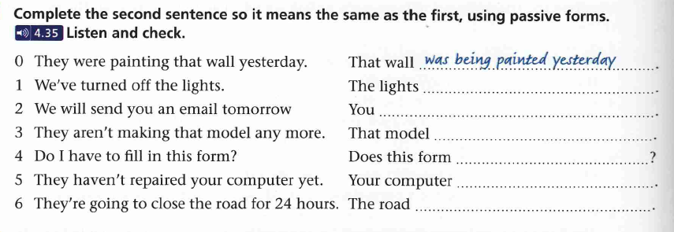



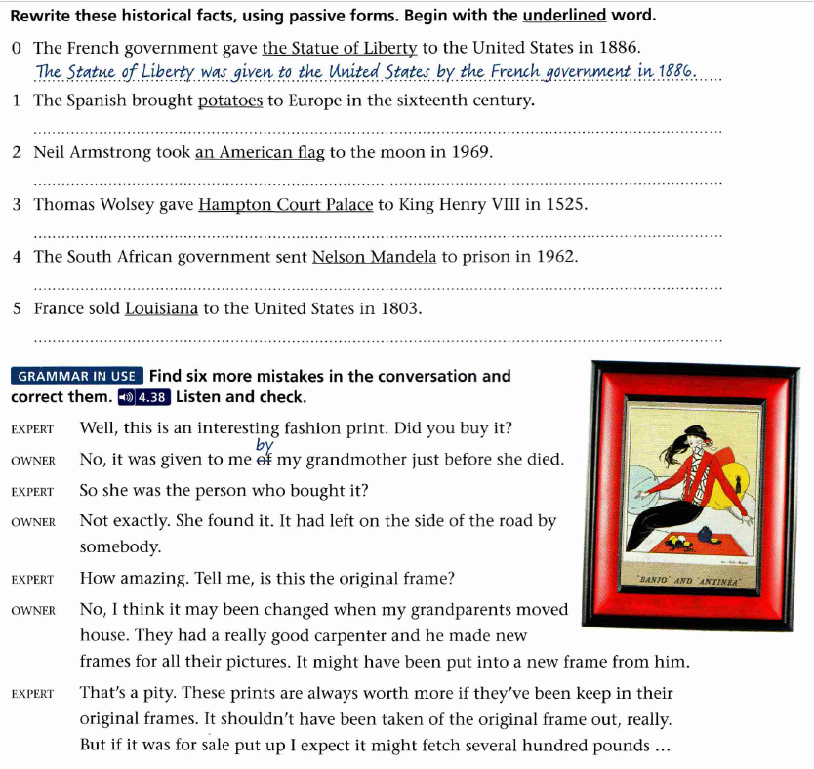

**Make presentations on each of the following topis:**

1 E-learning at the moment

2 Early educational technologies

3 Pollution nowadays and the outcome